Assignment 2:

Exercise 1: Create your first commit

* Initialize your Repository: git init project Exercise-1
* Create a file with name index.html
* Write code in newly created file
* Stage index.html
* Commit with message ‘Initial Message.’

Solution:

Exercise 2: Commit only one file.

* Initialize your Repository: git init Exercise-2
* Create a files with names index.html and about.html
* Add code in both files.
* Stage only one file.
* Commit with message: ‘File x added.’

Solution:

Exercise 3: Modify last commit.

* Initialize your Repository: git init project Exercise-3
* Create a file with name index.html
* Write code in newly created file
* Stage index.html
* Commit with message ‘adding index.html.’
* Add new about.html file with some code.
* Now modify message of previous commit as ‘Adding index.html and about.html ’and add about.html file in previous commit.

Solution:

Exercise 4: Create git ignore file

* Initialize your Repository: git init Exercise-4
* Create a gitignore file that will ignore
* all files with ‘exe’ extension
* all files with ‘o’ extension
* all files with ‘jar’ extension
* the whole libraries directory

Solution:

Exercise 5: Save your work with stash

* Initialize your Repository: git init Exercise-5
* Add some random files with code
* Now use git stash command to save required files from above files.
* (For this exercise don’t send repository just submit git commands and output of git stash list)

Solution:

Exercise 6: Reset Previous Commit Keeping changes. (Soft Reset)

* Initialize your Repository: git init Exercise-6.
* Do some series of commits.
* Now use git reset command to reset one of the commit and keep changes in staging area.
* In answer also add output of git status command.

Solution:

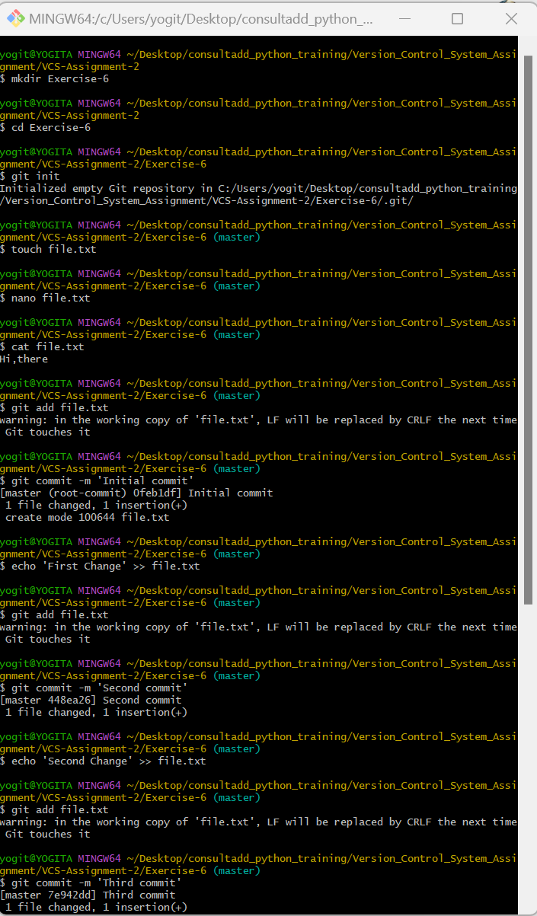

Exercise 7: Reset Previous Commit (Hard Reset).

* Initialize your Repository: git init Exercise-7.
* Do some series of commits.
* Use git reset command to reset one of the commit without keeping changes.

Solution:

Exercise 8: Merge branch (No Conflicts).

* Initialize your Repository: git init Exercise-8
* Create index.html file add some code.
* Make Commit.
* Create new branch from master branch with name my-feature.
* Add about-us.html file with code and commit changes in my-feature branch.
* Now checkout master branch.
* Merge my-feature branch into master.

Solution:

Exercise 9: Merge branch (Conflicts).

* Initialize your Repository: git init Exercise-9
* Create index.html file add some code.
* Make Commit.
* Create new branch from master branch with name my-feature.
* Add about-us.html file with code
* Make changes in index.html
* Commit changes in my-feature branch.
* Now checkout master branch.
* Do some code changes in index.html
* Commit changes.
* Now merge my-feature branch into master.
* You will get conflicts for index.html file. Resolve conflict by selecting both changes for the same index.html file.

Solution:

